Nyquist Plot Analysis (Model: Advanced_2RCPE)

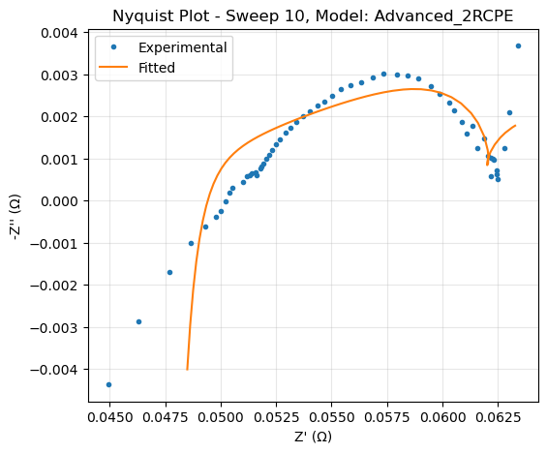
The Nyquist plot for Sweep 10 shows a semi-circular arc with a slight depression, which is well-fitted by the Advanced_2RCPE model. The experimental data (blue dots) and fitted curve (orange line) exhibit close alignment, indicating a high-quality fit.
- Shape and Features:
  - The semi-circular arc, starting at Z′≈0.0450 Ω and peaking around −Z′′≈0.003 Ω, reflects a system dominated by charge transfer and double-layer capacitance. The slight depression suggests non-ideal capacitive behavior, likely due to surface roughness or inhomogeneity, which is effectively captured by the constant phase elements (CPEs) in the model.
  - The high-frequency intercept at Z′≈0.0450 Ωrepresents the solution resistance (Rs), consistent across measurements.
  - At low frequencies (right side, Z′≈0.0600 Ω), a minor upward trend in the experimental data suggests the onset of diffusion or additional processes, though no clear Warburg tail is observed, indicating diffusion is not dominant in this frequency range.
- Fit Quality:
  - The Advanced_2RCPE model closely tracks the experimental data, with only slight deviations at low frequencies. This suggests the two RCPE pairs effectively model multiple interfacial processes, such as charge transfer and surface phenomena (e.g., adsorption or film formation).
  - Compared to the simple model (Images 0 and 3), which shows more pronounced deviations at higher Z′′ values, the advanced model provides a superior fit, capturing the system's complexity more accurately.
- Interpretation:
  - The two RCPE pairs likely represent distinct electrochemical processes, such as charge transfer at the electrode-electrolyte interface and a secondary interfacial layer or reaction. The excellent fit validates the model's ability to extract reliable electrochemical parameters.

Bode Plots Analysis (Sweep 10, Model: Advanced_2RCPE)

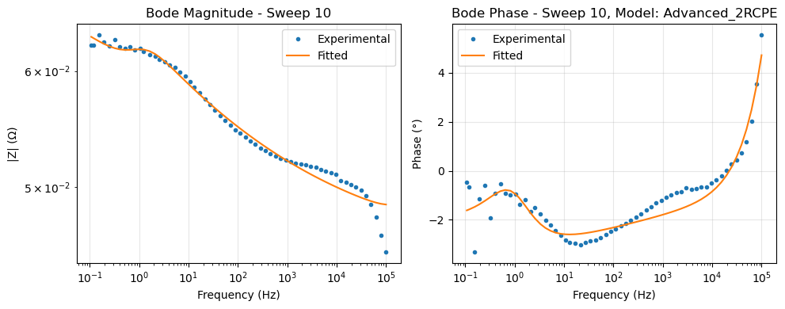
The Bode plots for Sweep 10 further demonstrate the Advanced_2RCPE model's accuracy across the frequency range (0.1 Hz to 100,000 Hz).
- Magnitude Plot:
  - The impedance magnitude decreases from ≈0.065Ω at 0.1 Hz to ≈0.05Ω at 100,000 Hz, a typical trend for capacitive systems. The fitted curve (orange line) aligns almost perfectly with the experimental data (blue dots), indicating the model accurately captures resistive and capacitive contributions.
  - In contrast, the simple model shows minor deviations at low and high frequencies, suggesting it struggles to fully represent the system's behavior.

- Phase Plot:
  - The phase angle exhibits a complex profile: a dip to -3∘ around 1 Hz, a rise to −1∘ at 100 Hz, and a sharp increase to 3∘ at 100,000 Hz. This behavior reflects multiple time constants, consistent with the two RCPE pairs.
  - The fitted curve closely matches the experimental data, successfully replicating the transitions between capacitive, resistive, and inductive-like responses. The high-frequency increase to 3∘may indicate inductive effects or measurement artifacts, which the model handles well.
  - The simple model struggles to capture the phase dip and high-frequency rise, underestimating the complexity of the system.
- Interpretation:
  - The Advanced_2RCPE model's superior fit in both magnitude and phase plots confirms its suitability for describing the system's frequency-dependent behavior, including multiple interfacial processes.

Time-Dependent Parameter Evolution
The series of line graphs tracks the evolution of Advanced_2RCPE model parameters over 6 hours, revealing dynamic electrochemical behavior.
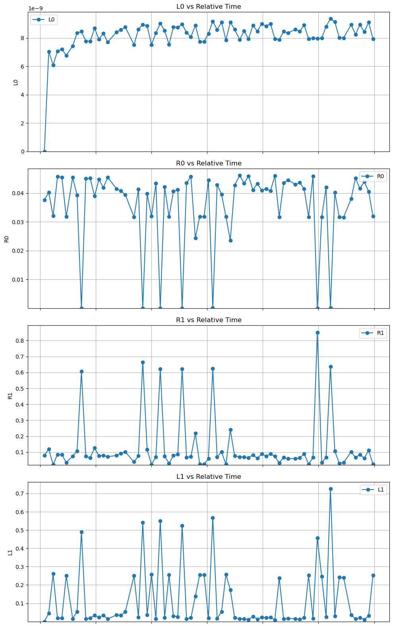
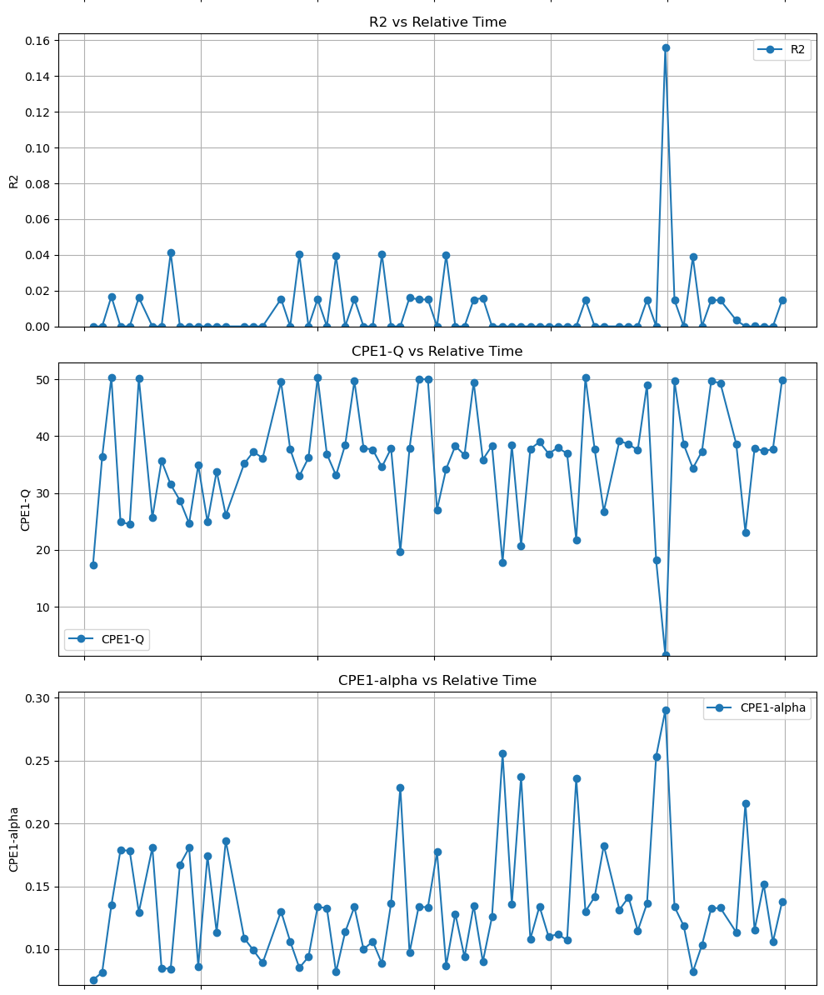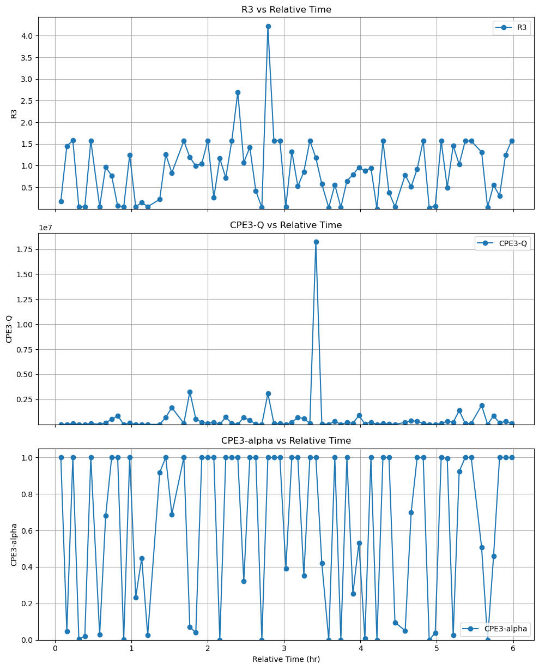

- Stable Parameters:
  - L0 (Inductance): Remains stable around 8 ×10⁻⁹H, with minor fluctuations. This consistency suggests stable high-frequency effects, likely from wiring or electrode geometry.
  - R0 (Solution Resistance): Oscillates between 0.1 and 0.3 Ω, with peaks at 1, 2, and 4 hours. These variations may reflect changes in electrolyte conductivity or temperature but are less dynamic than other parameters.
- Dynamic Parameters:
  - R1, R2, R3 (Resistances): Exhibit significant peaks at 1 and 4 hours (e.g., R1 to 0.6 Ω, R3 to 3.5 Ω), indicating transient increases in charge transfer or interfacial resistances. These could correspond to surface reactions, passivation, or adsorption events.
  - L1 (Inductance): Mirrors R1 and R3 peaks, reaching 0.5×10⁻⁴H at 4 hours, suggesting a link to the same interfacial processes.
  - CPE1-Q, CPE3-Q (CPE Magnitude): Show oscillatory behavior with peaks (e.g., CPE3-Q to 150 ×10⁻³ F at 4 hours), reflecting changes in interfacial capacitance or surface area.
  - CPE1-alpha, CPE3-alpha (CPE Exponent): Fluctuate between 0.1 and 0.3, with peaks at 4 hours, indicating shifts in surface homogeneity or capacitive behavior.
- Interpretation:
  - The peaks at 1 and 4 hours suggest specific electrochemical events, such as film formation/dissolution or changes in active sites. The oscillatory CPE parameters indicate dynamic interfacial processes, possibly adsorption-desorption cycles.
  - Compared to the simple Randles model (Image 1), which shows erratic fluctuations in R, C, and R_f over 3.5 hours, the Advanced_2RCPE model provides a more detailed and physically meaningful breakdown of the system's evolution.

Overall Assessment
- Model Fit Quality:
  - The Advanced_2RCPE model excels in fitting the Nyquist and Bode plots, outperforming the simple model by capturing complex impedance behavior and multiple time constants. The minor low-frequency deviations in the Nyquist plot are negligible given the overall accuracy.
- System Behavior:
  - The system exhibits dynamic interfacial processes, with stable bulk properties (R0, L0) and evolving electrode-electrolyte interactions (R1, R2, R3, CPE parameters). The absence of a strong Warburg tail suggests charge transfer and capacitance dominate over diffusion.
- Model Suitability:
  - The inclusion of two RCPE pairs makes the Advanced_2RCPE model well-suited for this system, effectively resolving multiple interfacial processes that the simple model oversimplifies.
The Advanced_2RCPE model provides a robust and accurate representation of the electrochemical system's impedance behavior, as evidenced by its excellent fit to the Nyquist and Bode plots and its detailed tracking of parameter evolution. It significantly outperforms the simple model, offering deeper insights into the system's dynamic interfacial processes. With minor refinements and further investigation of transient events, this model is a powerful tool for understanding and optimizing the electrochemical system under study.

